ASSIGNMENT CO1

C++

Name: C. Pavani
Register Number: 192524260
Total Marks: 100

Title: Design, Implement and Validate the Fare Logic of a City Metro Smart-Card System.

Task 1 – Understand the Problem and Identify Objects

Aim: To understand the metro smart-card system and identify its main objects.
Answer:
A metro smart-card system is used by passengers to travel on the metro. Passengers add money to their smart cards, and the fare is deducted after each journey.
The main objects are:
- Passenger: The person who travels by metro.
- Smart Card: Stores the passenger's balance.
- Metro Station: The station where passengers enter and exit.
- Journey: Represents the passenger's travel.
- Fare Calculator: Calculates the journey fare.

Result: The main objects of the metro smart-card system are identified.

Task 2 – Identify Tokens, Keywords, Identifiers and Constants

Aim: To identify the basic elements of a C++ program.
Answer:
- Tokens: Smallest individual elements of a program.
- Keywords: Reserved words such as int, float, if, else, and return.
- Identifiers: Names given to variables and functions, such as balance and fare.
- Constants: Fixed values that cannot be changed, such as 10, 20, and 30.
Example:

#include <iostream>
using namespace std;

int main() {
int balance = 500;
const int fare = 10;

cout << balance - fare;
return 0;
}

Output:
490
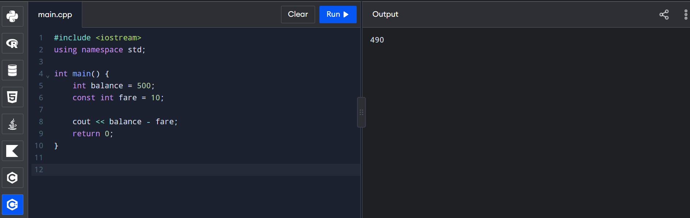

Result: Tokens, keywords, identifiers and constants are identified.

Task 3 – Data Types and Type Compatibility

Aim: To understand different data types used in C++.
Answer:
Data type | Purpose | Example
int | Stores whole numbers | 100
float | Stores decimal numbers | 10.5
double | Stores large decimal values | 25.75
char | Stores a single character | 'A'
bool | Stores true or false | True
For the metro system:
- int can store passenger ID.
- double can store fare values.
- bool can store pass validity.
- char can store a category symbol.

Program:

#include <iostream>
using namespace std;

int main() {
int passengerID = 101;
double balance = 500.50;
bool validCard = true;

cout << passengerID << endl;
cout << balance << endl;
cout << validCard << endl;

return 0;
}
Output:

101
500.5
1
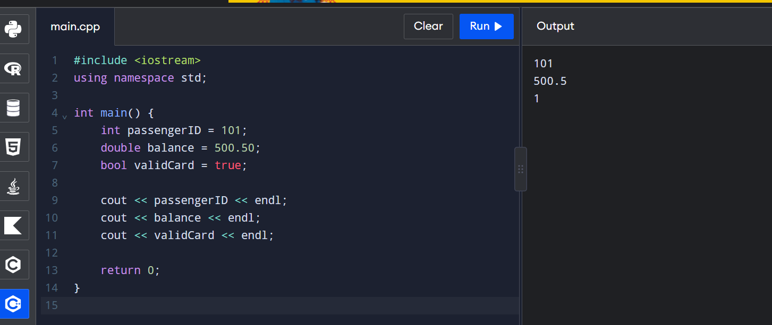

Result: Different C++ data types are used to store metro card information.

Task 4 – Implicit Type Conversion

Aim: To understand automatic type conversion in C++.

Answer:
Implicit type conversion happens automatically when one data type is converted into another data type.

Program:

#include <iostream>
using namespace std;

int main() {
int a = 3;
double b = 3.5;

cout << a << " " << b << endl;

char ch = 'C';
int value = ch;

cout << ch << " " << value << endl;

bool x = 1;
cout << x << " " << boolalpha << x << endl;

int s = 10;
double u = 20.5;

if (s < u)
cout << "s < u";
else
cout << "s >= u";

return 0;
}

Output:
3 3.5
C 67
1 true
s < u
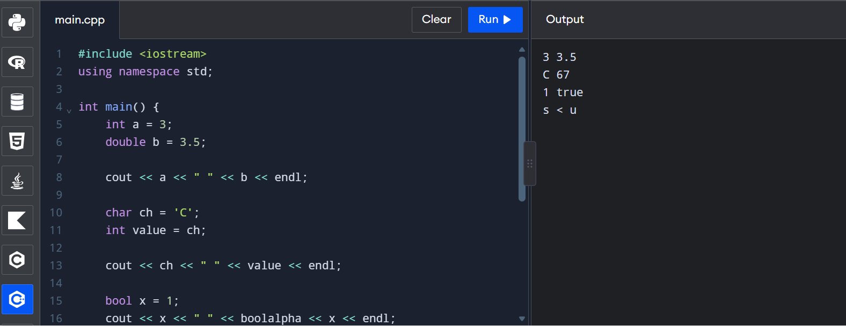
Result: Implicit conversion is demonstrated using integer, double, character and Boolean values.

Task 5 – Operators and Operator Precedence

Aim: To understand operators and their priority in C++.

Answer:
Operators are symbols used to perform operations.
- Arithmetic: +, -, *, /, %
- Relational: >, <, ==, !=
- Logical: &&, ||, !
- Assignment: =, +=, -=

Program:

#include <iostream>
using namespace std;

int main() {
int a = 5, b = 2;

cout << a + b * 3 << endl;
cout << (a + b) * 3 << endl;

cout << a / b << " " << a % b << endl;

cout << (a > b) << endl;

return 0;
}
Output:
11
21
2 1
1
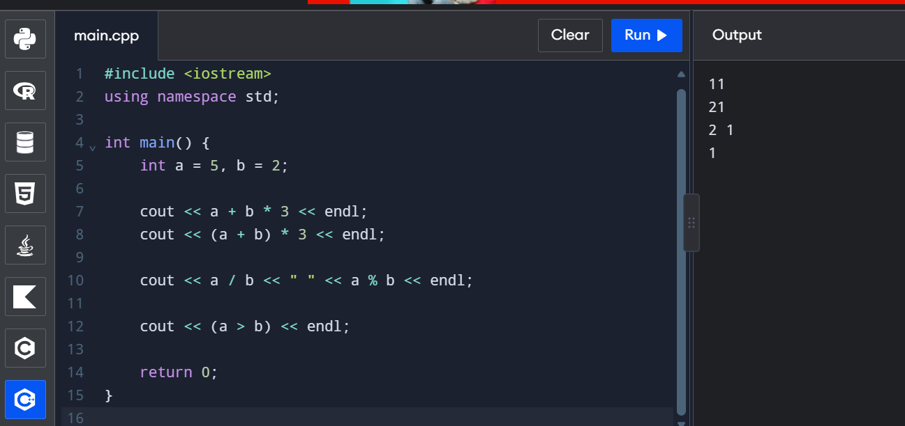

Result: Different operators and their precedence are demonstrated.

Task 6 – Control Structures

Aim: To use decision-making statements in a metro fare system.

Answer:
Control structures are used to control the execution of a program.
- if: Executes a block when a condition is true.
- if-else: Selects one of two blocks.
- switch: Selects a case.
- for and while: Repeat statements.

Pseudocode:

BEGIN
READ balance
READ fare

IF balance >= fare THEN
balance = balance - fare
PRINT balance
ELSE
PRINT "Insufficient Balance"
ENDIF
END

C++ Program:

#include <iostream>
using namespace std;

int main() {
int balance = 500;
int fare = 30;

if (balance >= fare) {
balance = balance - fare;
cout << "Remaining Balance: " << balance;
}
else {
cout << "Insufficient Balance";
}

return 0;
}

Output:
Remaining Balance: 470
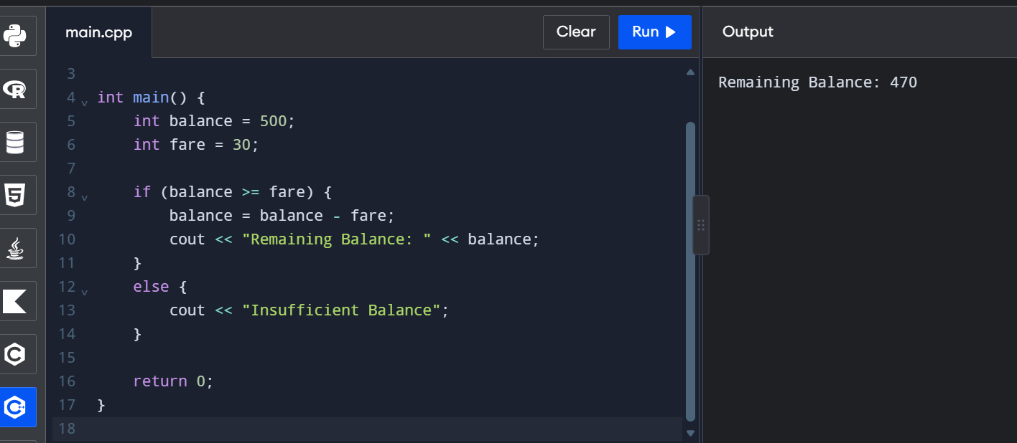
Result: The if-else control structure is used to check the smart-card balance.

Task 7 – Procedural Programming and Object-Oriented Programming

Aim: To compare procedural programming and object-oriented programming.

Answer:
Procedural Programming | Object-Oriented Programming
Uses functions | Uses classes and objects
Focuses on procedures | Focuses on objects
Data and functions are separate | Data and functions are combined
Example: C | Example: C++
C++ Program:
#include <iostream>
using namespace std;

class SmartCard {
public:
int balance;

void display() {
cout << "Balance: " << balance;
}
};

int main() {
SmartCard card;
card.balance = 500;

card.display();

return 0;
}

Output:
Balance: 500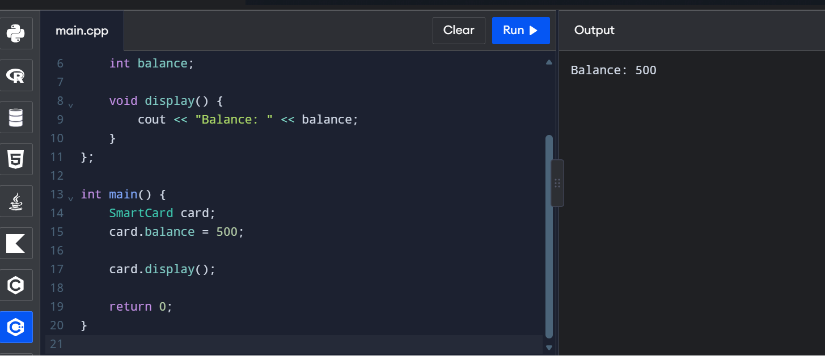

Result: Object-oriented programming is demonstrated using a SmartCard class.

Task 8 – Safe Input and Output

Aim: To read passenger details and display them safely.

Answer:
Safe input means checking the input before using it. It helps avoid invalid values and program errors.

Program:
#include <iostream>
#include <limits>
using namespace std;

int main() {
int balance;

cout << "Enter balance: ";

if (!(cin >> balance) || balance < 0) {
cout << "Invalid input";
return 0;
}

cout << "Balance: " << balance;

return 0;
}

Sample Output:
Enter balance: 500
Balance: 500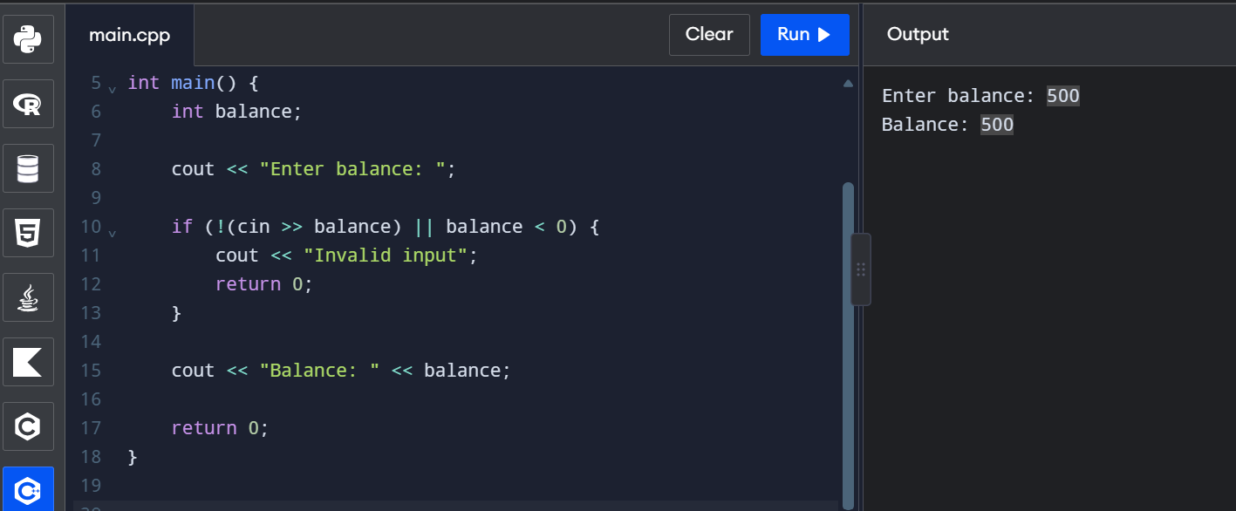

Result: Safe input validation is implemented using cin.

Task 9 – Implement and Test Fare Logic

Aim: To calculate metro fare and deduct it from the smart-card balance.

Answer:
The metro fare depends on the travel zone.
Zone | Fare
Inner | Rs. 10
Middle | Rs. 20
Outer | Rs. 30
A 20% peak-hour surcharge is applied during peak hours. The remaining balance must be at least Rs. 50 after the journey.

C++ Program:
#include <iostream>
using namespace std;

int main() {
int balance = 500;
int fare = 30;
int hour = 9;

if (hour >= 8 && hour < 10)
fare = fare + (fare * 20 / 100);
else if (hour >= 17 && hour < 20)
fare = fare + (fare * 20 / 100);

if (balance - fare >= 50) {
balance = balance - fare;
cout << "Fare: " << fare << endl;
cout << "Remaining Balance: " << balance;
}
else {
cout << "Insufficient Balance";
}

return 0;
}
Output:
Fare: 36
Remaining Balance: 464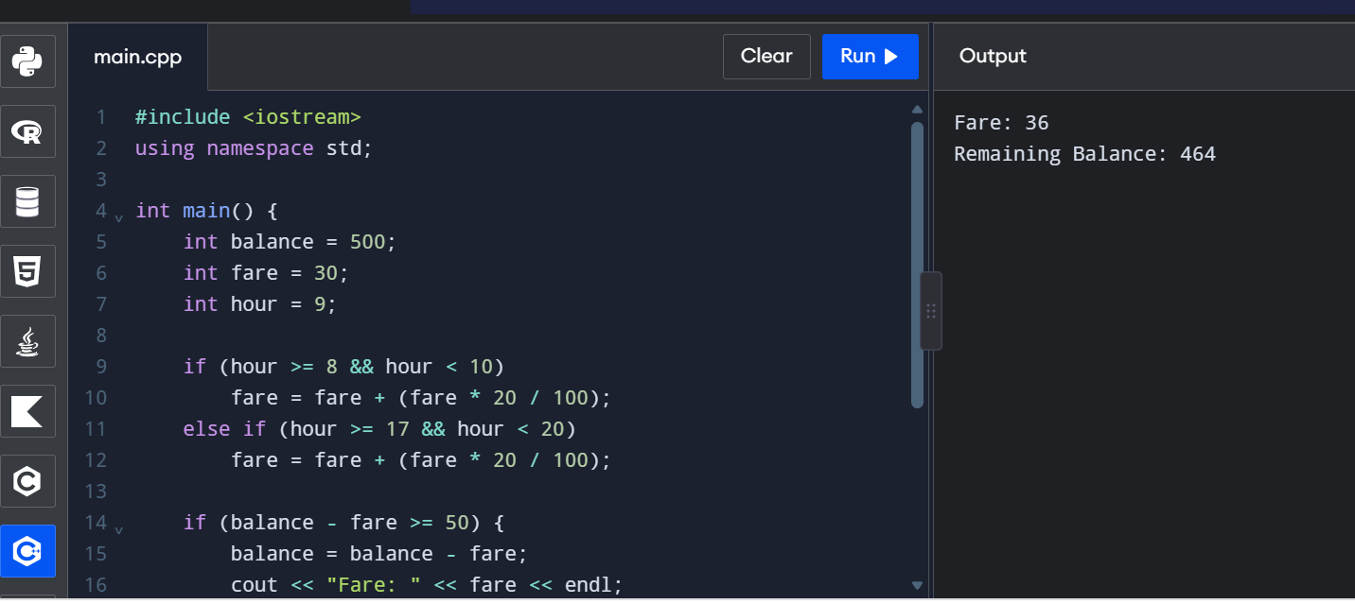

Result: Metro fare is calculated and deducted according to the peak-hour condition.

Task 10 – Compare Expected and Actual Execution

Aim: To compare the expected output with the program output.

Answer:
Assume 20,000 passengers travel per day and each passenger pays Rs. 30.

Days | Expected Collection
1 day | Rs. 6,00,000
25 days | Rs. 1,50,00,000
150 days | Rs. 9,00,00,000
Calculation:
Daily collection = 20,000 × 30 = Rs. 6,00,000.
25-day collection = 6,00,000 × 25 = Rs. 1,50,00,000.
150-day collection = 6,00,000 × 150 = Rs. 9,00,00,000.

Result: Expected fare collection is calculated for different periods. Compare these values with your actual program execution.

Task 11 – Recommend the Final Design

Aim: To recommend a suitable design for the metro smart-card system.
Answer:
The recommended design should use:
- Classes and objects to manage smart cards.
- Integer paise to store money accurately.
- Input validation to prevent invalid data.
- Functions to calculate fares.
- Conditional statements to apply peak-hour charges.
- Proper balance checking before fare deduction.

Result: An object-oriented design with safe input and accurate money calculations is recommended.

Task 12 – Day-4 Design Challenge

Aim: To improve the metro smart-card system by adding new features.

Answer:
The improved system includes:
- Airport Zone: The airport fare is Rs. 60.
- Weekend Discount: A 10% discount is provided on weekends.
- Peak Surcharge: A 20% surcharge is applied during peak hours. It cannot be combined with the weekend discount.
- Monthly Pass: Passengers can select two zones and travel unlimited times in those zones during the pass period.

C++ Program:
#include <iostream>
using namespace std;

int main() {
int fare = 60;
int balance = 500;
bool weekend = true;
bool peak = false;

if (weekend) {
fare = fare - (fare * 10 / 100);
}
else if (peak) {
fare = fare + (fare * 20 / 100);
}

if (balance - fare >= 50) {
balance = balance - fare;

cout << "Final Fare: " << fare << endl;
cout << "Remaining Balance: " << balance;
}
else {
cout << "Insufficient Balance";
}

return 0;
}

Output:
Final Fare: 54
Remaining Balance: 446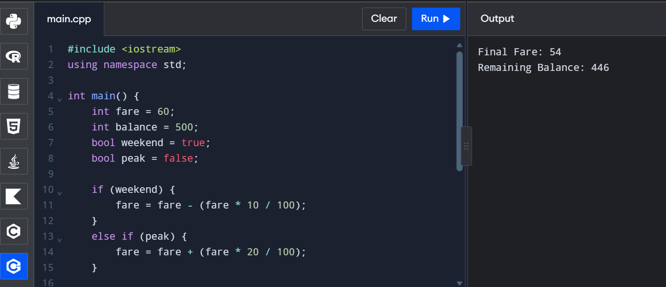
Result: The improved metro fare system demonstrates airport fare, weekend discount, peak surcharge and balance checking. The monthly pass feature is explained in the design; it is not implemented in this sample program.

